CMPR 121 - Fall 2022

Miguel Basilio

Mb05857

# Lab 7 (15 Points) Due Date: 10/15/22 @ 11:59PM



Lab 7 has two parts.

Please complete Part 1 and Part 2 to receive full credit for Lab 7

**Part 1: (10 Points)**

# Short answers and fill in the blank

‘ ‘ single quotation

“ “ double quoatation

cctype

In the Garden of Eden

22 (characters)

24

\n null character

#

0

boolean

B

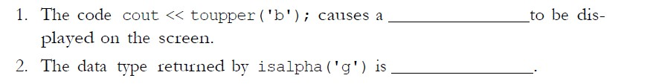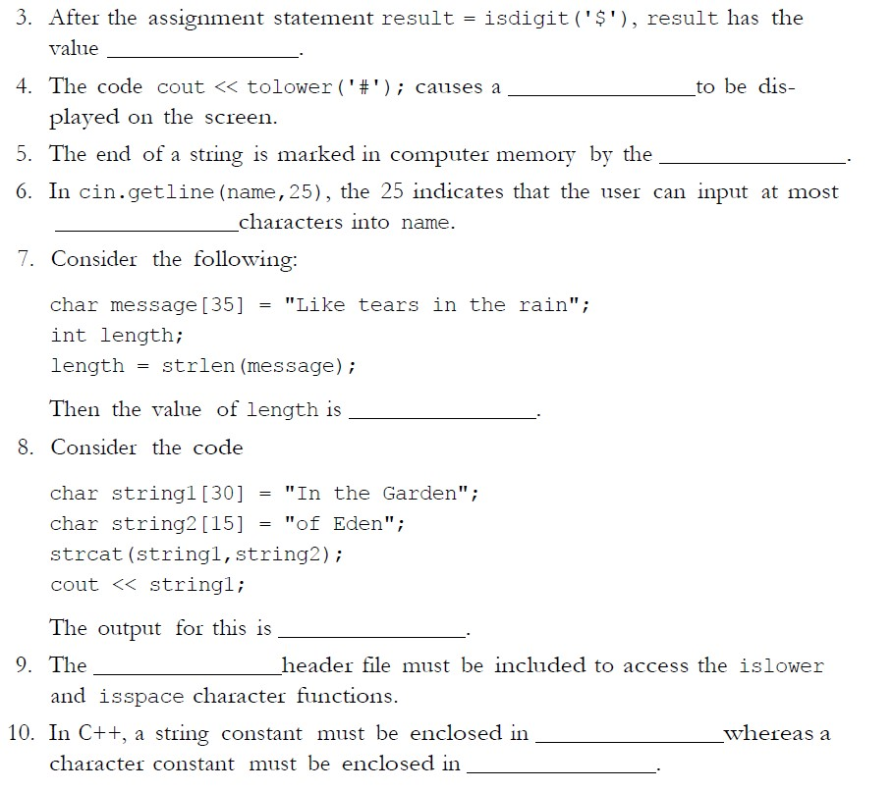

Page 1 of 2

Miguel Basilio

Mb05857

CMPR 121 - Fall 2022

**Lab 7 (15 Points) Due Date: 10/15/22 @ 11:59PM**



**Part 2: (5 Points)**

# Wiritng a Program

Write a function that accepts an int array and the array’s size as arguments. The function should create a copy of the array, except that the element values should be reversed in the copy. The function should return a pointer to the new array. Demonstrate the function in a driver program.

**Here are few tips:**

* Function prototype:

int* reverseArray(int arr[], int size);

* We are creating a new array. We are not simply printing the array in reverse.

* We need to return a pointer of the newly created array which elements are now in reversed order compared to the original.

* Do not sort the array.

* Here is a Sample Run of the program

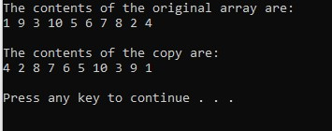

#include <iostream>

using namespace std;

/* reversing arr[] from start to end*/

void rvereseArray(int arr[], int start, int end)

{

while (start < end)

{

int temp = arr[start];

arr[start] = arr[end];

arr[end] = temp;

start++;

end--;

}

}

/* print an array */

void printArray(int arr[], int size)

{

for (int i = 0; i < size; i++)

cout << arr[i] << " ";

cout << endl;

}

int main()

{

/* Driver */

int arr[] = { 1, 9, 3 ,10, 5, 6,7, 8 ,2, 4};

int n = sizeof(arr) / sizeof(arr[0]);

// print original array

printArray(arr, n);

// calling reversed array

rvereseArray(arr, 0, n - 1);

cout << "Reversed array is" << endl;

printArray(arr, n);

return 0;

}

=========================== **End of Lab # 7** =================================